4th ANNUAL KIDS KICKING CANCER
BENEFIT GOLF TOURNAMENT, FRIDAY MARCH 24, 2017
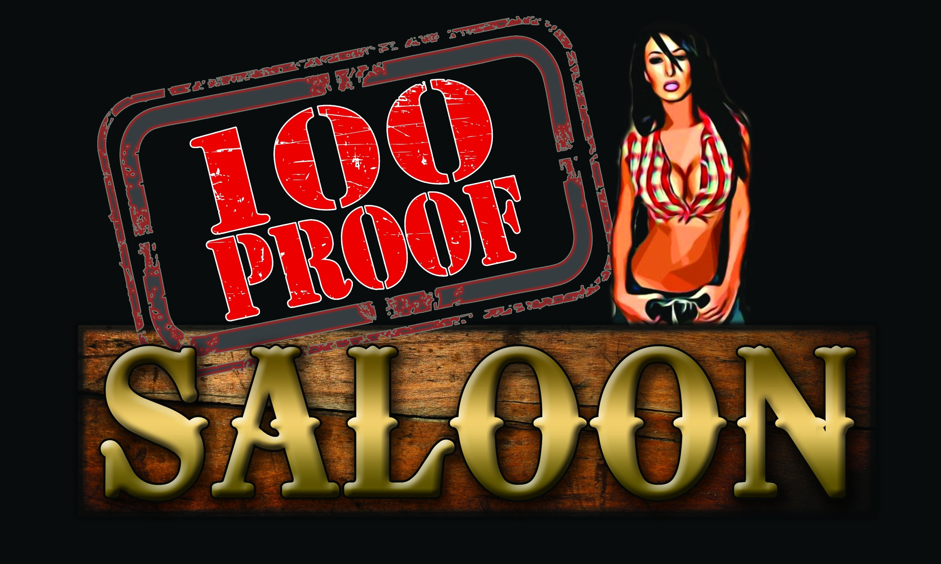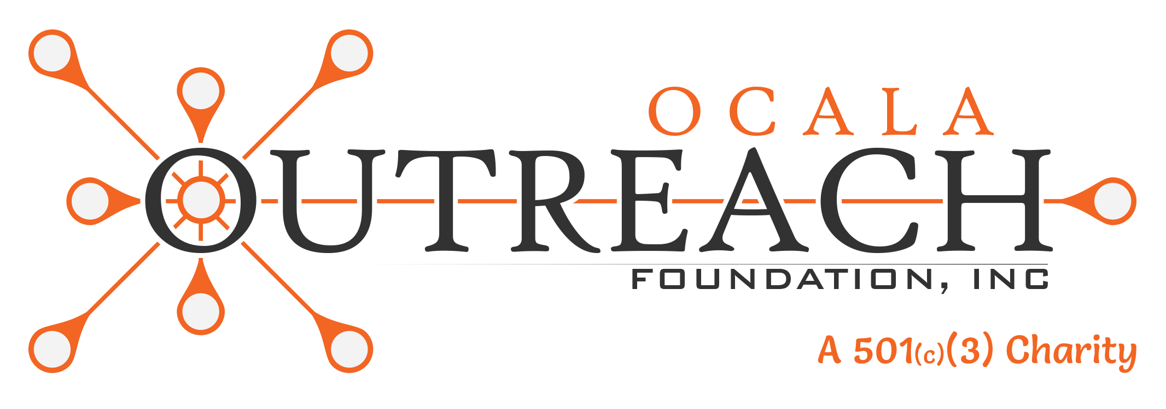
PRESENTED BY 100 PROOF SALOON AND FASTTRACK STAFFING FOR OCALA OUTREACH’S CHILDREN’S CANCER PATIENT’S ASSISTANCE PROGRAM
The Country Club at Silver Springs Shores, 633 Silver Road, Ocala, Fl
This tournament is being held to raise money for Ocala Outreach, a local charity that assists everyone in Marion County. The money raised at this event specifically goes to mortgage/rent, utilities, gas and food gift cards of families with children battling cancer. There are several children in our area that need assistance.
The cost is $100 a player which includes green fees, cart, food, beverages (alcoholic and nonalcoholic), shirt and many more great items, along with awesome raffle prizes. Several restaurants and businesses will be on the course with different foods and products.
This is a 3-man scramble format. Two 3-man teams will be paired together for the round.
Registration starts at 9:30 am with range balls being provided. Tee off is promptly at 12:30pm.
Please make checks payable to "Ocala Outreach".

SPONSORSHIPS ARE AVAILABLE!
If you have any questions or would like to register, please contact Dan Clark at
352-425-1089 or Dan@ocala.events.
Platinum Sponsors
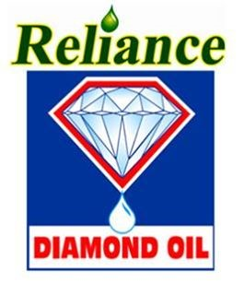
Food Vendors
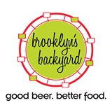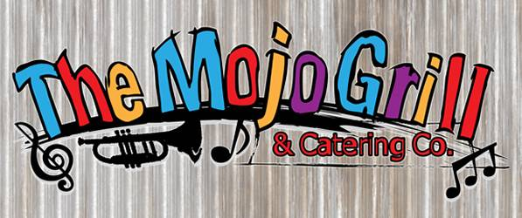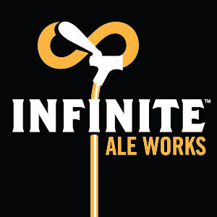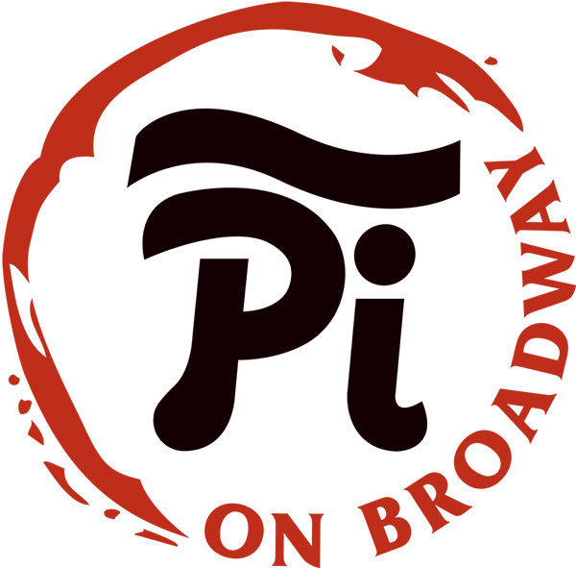
4TH ANNUAL KIDS KICKING CANCER
BENEFIT GOLF TOURNAMENT, FRIDAY MARCH 24, 2017

PLAYER INFORMATION

Player #1 Name:_______________________________________________
E-Mail Address:______________________ Phone Number:______________
Shirt Size:________

Player #2 Name:_______________________________________________
E-Mail Address:______________________ Phone Number:______________
Shirt Size:________

Player #3 Name:_______________________________________________
E-Mail Address:______________________ Phone Number:______________
Shirt Size:________

To ensure you get your shirt size, please RSVP by March 17, 2017

If you have any questions or would like to register, please contact Dan Clark at
352-425-1089 or Dan@ocala.events.
Platinum Sponsors
Food Vendors

