5th ANNUAL KIDS KICKING CANCER
BENEFIT GOLF TOURNAMENT, FRIDAY MARCH 23, 2018
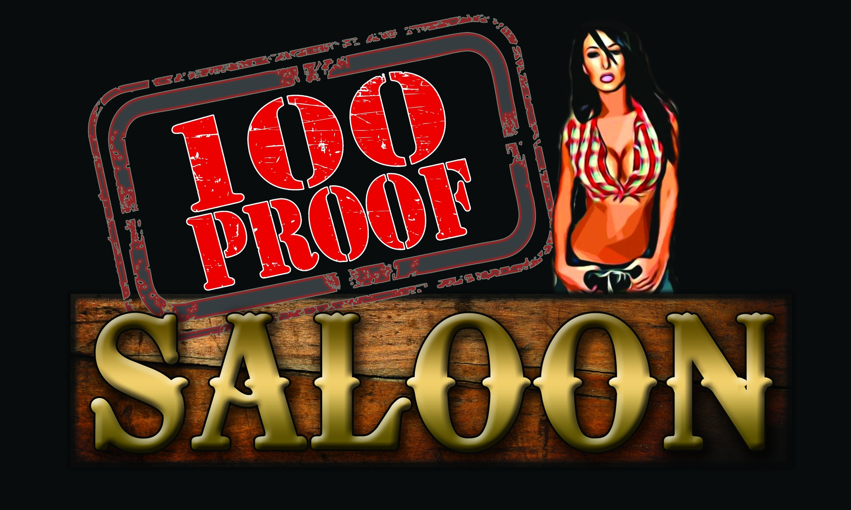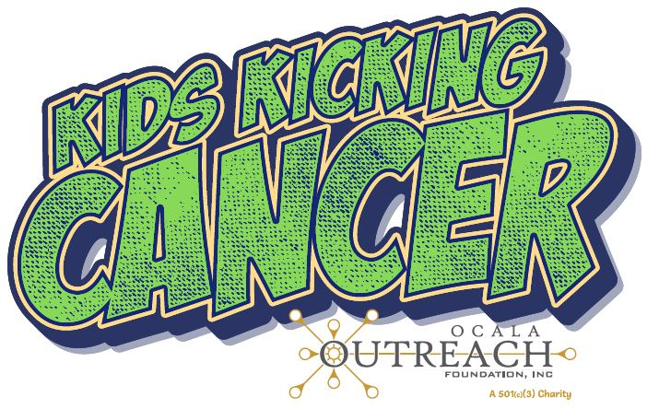
PRESENTED BY 100 PROOF SALOON AND FASTTRACK STAFFING FOR OCALA OUTREACH’S CHILDREN’S CANCER PATIENT ASSISTANCE PROGRAM
OCALA GOLF CLUB, 3130 E SILVER SPRINGS BLVD, Ocala, Florida
This tournament is being held to raise money for Ocala Outreach, a local charity that assists everyone in Marion County. The money raised at this event specifically goes to mortgage/rent, utilities, gas and food gift cards of families with children battling cancer. There are several children in our area that need assistance.
SPONSORSHIP LEVELS
$2,500 and up – Corporate Sponsor – (includes two 3-man teams, tent at clubhouse, Logo on top of
all literature, speaker at the event, banner and plaque)
$1,000 – Platinum Sponsor (includes 1 3-man team, have a tent at the club house from the beginning
to the end, a banner and plaque)
$500 – Gold Sponsor (This is for setting up at 1 of 8 holes that have road access on the course includes
a banner and a plaque)
$250 – Silver Sponsor (This is for setting up tables at 1 of 10 holes without road access. We will have
personnel to help take your supplies to the hole)
$150 – Bronze Sponsor (Hole Sponsor) (This is a hole sponsor, you will have a sign set up on the Tee
Box, $100 if you are playing in or assisting with the tournament)
At the end of the tournament, all sponsors on the course can transfer to the clubhouse for the awards ceremony. Corporate and Platinum sponsors get pick of location.
Your sponsorships are greatly appreciated by Ocala Outreach and families battling cancer within the community.

Please make checks payable to "Ocala Outreach".

If you have any questions or would like to register, please contact Dan Clark at
352-425-1089 or d.clark@fasttrackse.com.
5th ANNUAL KIDS KICKING CANCER
BENEFIT GOLF TOURNAMENT, FRIDAY MARCH 23, 2018
Sponsorship Information
Sponsor Name: _____________________________________
Contact Name: _____________________________________
Contact Phone Number: _____________________________________
Address: _____________________________________
Email: _____________________________________
Type of Sponsorship: __ Corporate Sponsorship ($2,500 and up) (Please
also fill out 2 player forms for your teams)
__ Platinum Sponsorship ($1,000) (Please also fill
out a player form for your team)
__ Gold Sponsorship ($500) (8 Available)
__ Silver Sponsorship ($250) (10 Available)
__ Bronze Sponsorship ($150) ($100 if you are
playing in or assisting with the tournament)

***Please e-mail your logo in PDF or CDR format with a file size of 500kb or higher to
d.clark@fasttrackse.com.

Please make checks payable to “Ocala Outreach”.

